Lab6 Exercises
load ISwR library.
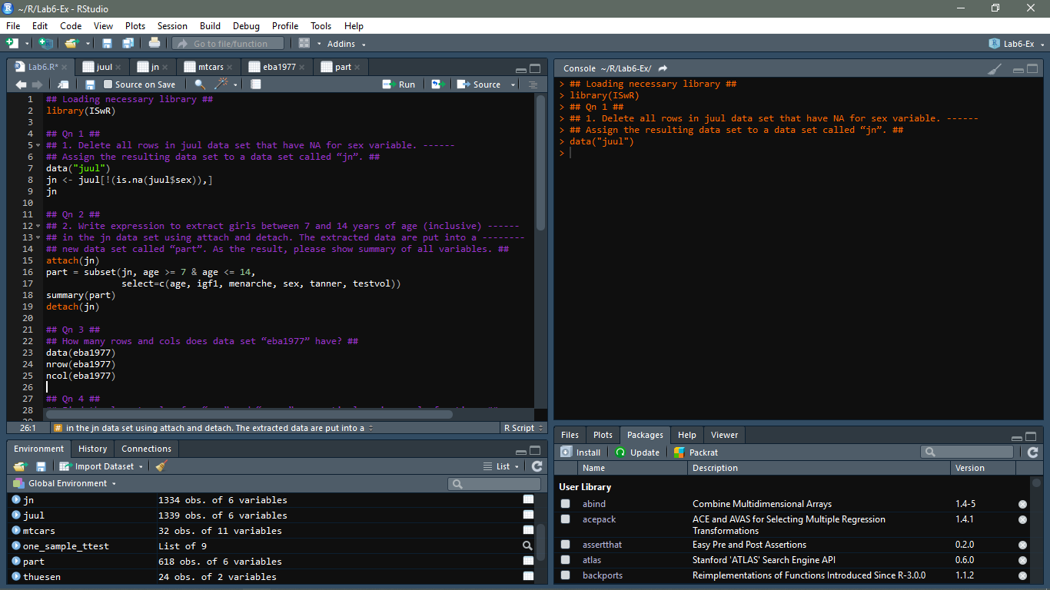
1. Delete all rows in juul data set that have NA for sex variable. Assign the resulting data set to a data set called “jn”.

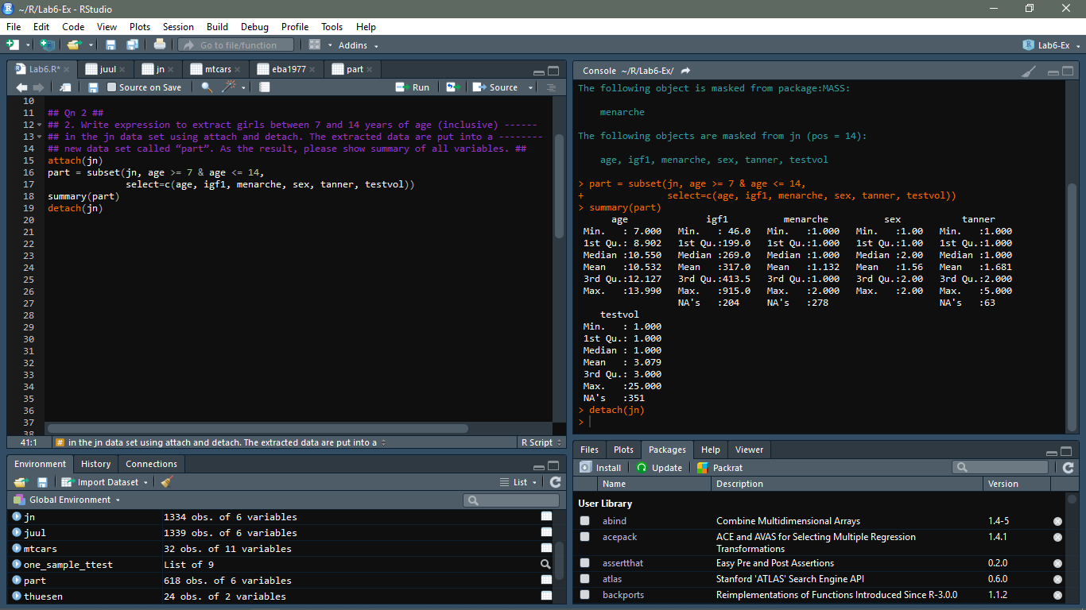
2. Write expression to extract girls between 7 and 14 years of age (inclusive) in the jn data set using attach and detach. The extracted data are put into a new data set called “part”. As the result, please show summary of all variables.

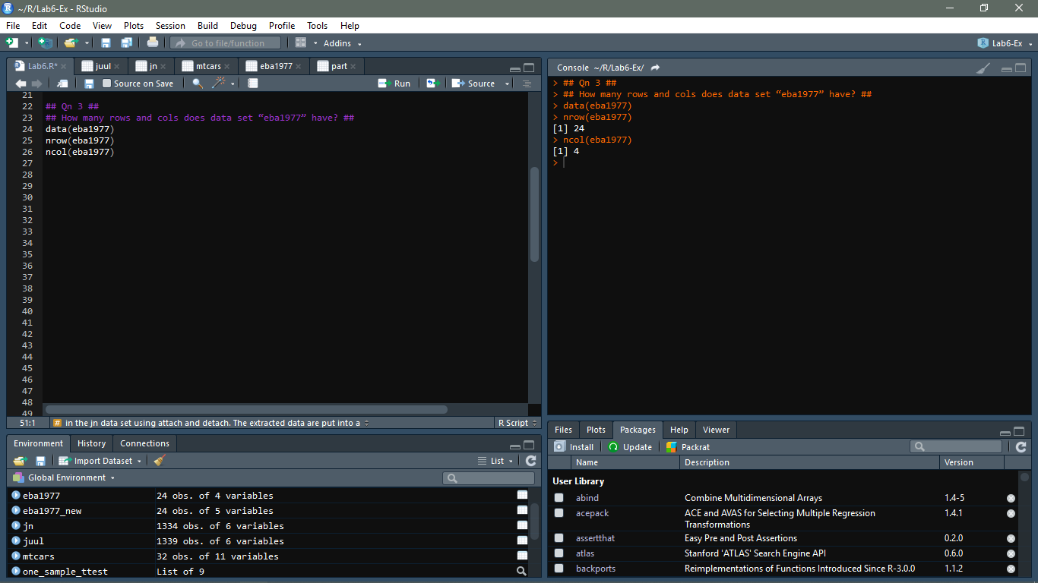
3. How many rows and cols does data set “eba1977” have?

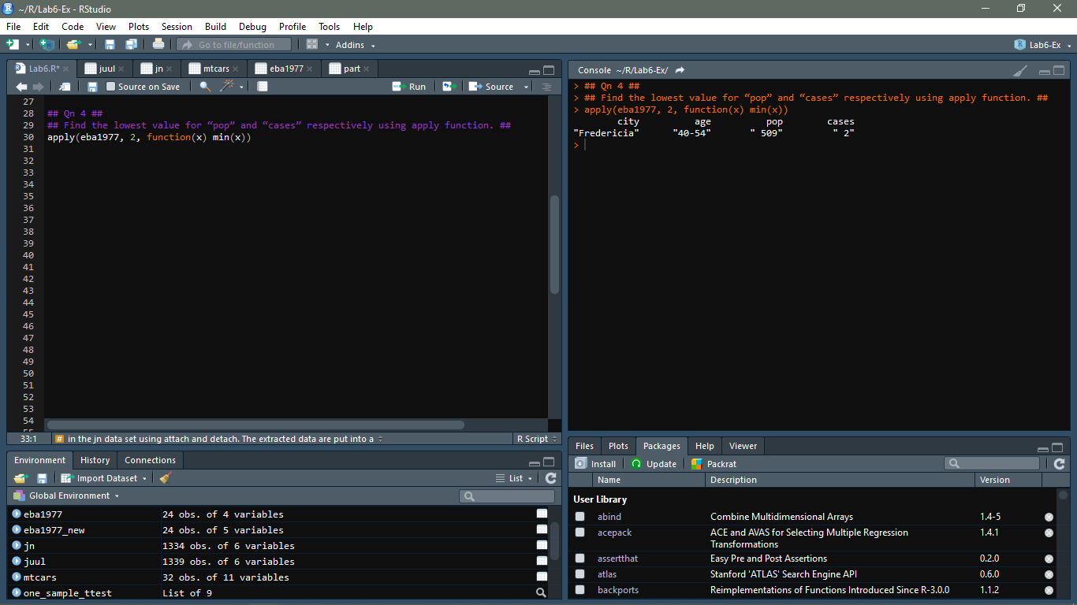
4. Find the lowest value for “pop” and “cases” respectively using apply function.

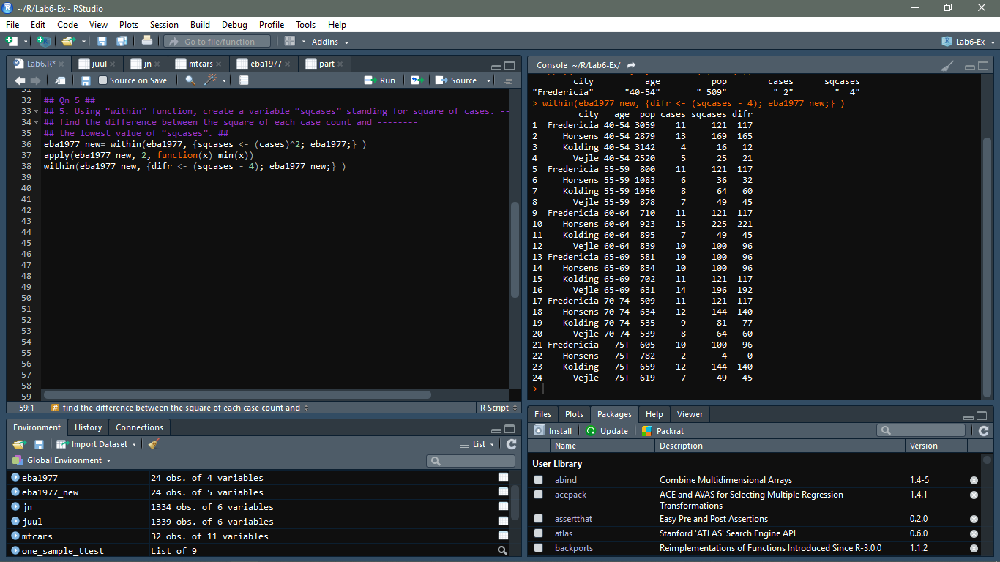
5. Using “within” function, create a variable “sqcases” standing for square of cases. find the difference between the square of each case count and the lowest value of “sqcases”.

6. Using mtcars data set and tapply function, please find the average disp by cyl and am.
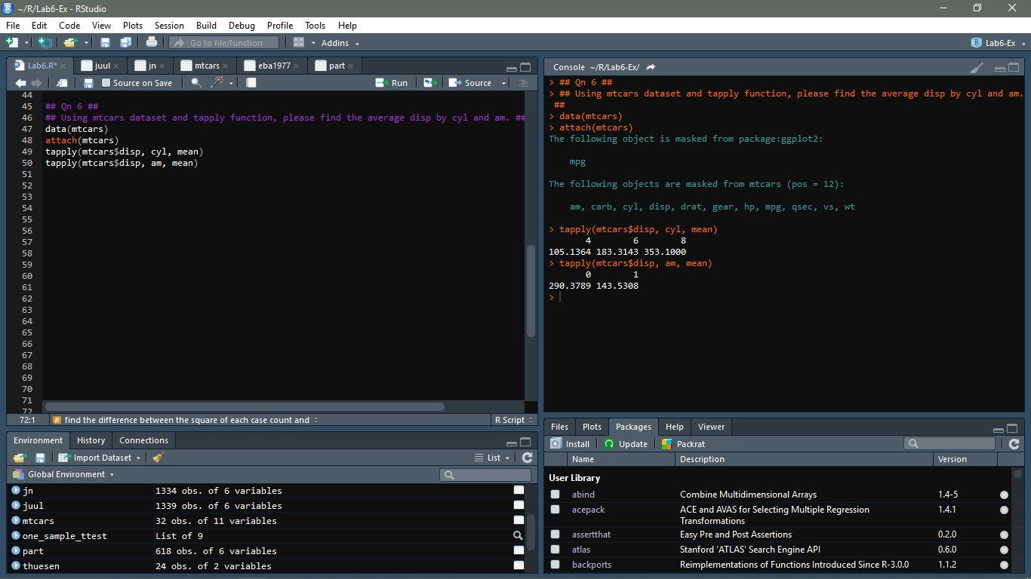

7. For the data set rat from “UsingR”, do a one-sample t-test for mean against 112 using p value based on R outputs. What is your conclusion? Please replicate the p value from R outputs?
